Assignment #2 Comparing Economic Systems
You have just been hired in the marketing division of a large company in Atlanta
that produces toys. The products are typically sold through large retail store
chains. The Vice President for Marketing has assigned you your first project. She
has asked you to conduct some early research to help in the decision of entering
the Mexico market first or the China market with the company's products. You
recall in a business course in college hearing about the CIA World Factbook and
think that would be a good place to begin your research.
(https://www.cia.gov/library/publications/the-world-factbook/)
After locating information about Mexico and China, you think your VP will want to
know this information about the country options:
1. Where are the countries located? How large are they in area?
2. What is the population? Since your products are obviously targeted to
younger consumers, how many people are under the age of fifteen?
3. Is the economy a market-based, planned, or mixed? What effect would this
have on the company’s operations? Freedom of movement? Funding options?
4. What is the GDP per capita?
5. What is the unemployment rate?
Based on your investigation, take a position on which country would be best
for the toy company to expand into first. Compose a one-page memo to
your VP summarizing your findings and your recommendation. Be sure to
defend your recommendation using your findings (and not your opinions or
feelings).

Assignment #3 & #4 Today’s Banking Environment
#3 In D2L”WEEK 3 Banking Environment” file you will find a form (or
“template”) for Assignment #3’s study of Today’s Banking Environment.
Visit the FDIC’s website at
https://www.fdic.gov/bank/individual/failed/banklist.html and (1) count the
number of US bank failures per year, beginning in 2000 (“Closing Date”).
Now go back to the list and (2) look for banks that were closed in Georgia
from 2000 to 2017 (arrange chart by state). Fill in the Assignment #3
template located in D2L under WEEK 3 “Banking Environment” tab.

Business Portfolio Assignment #3

Analyzing Todays Banking Environment

INSTRUCTIONS: To collect the data needed for this Portfolio Assignment #3, click on http://www.fdic.gov/bank/individual/failed/banklist.html and look at the table of “Failed Bank”.

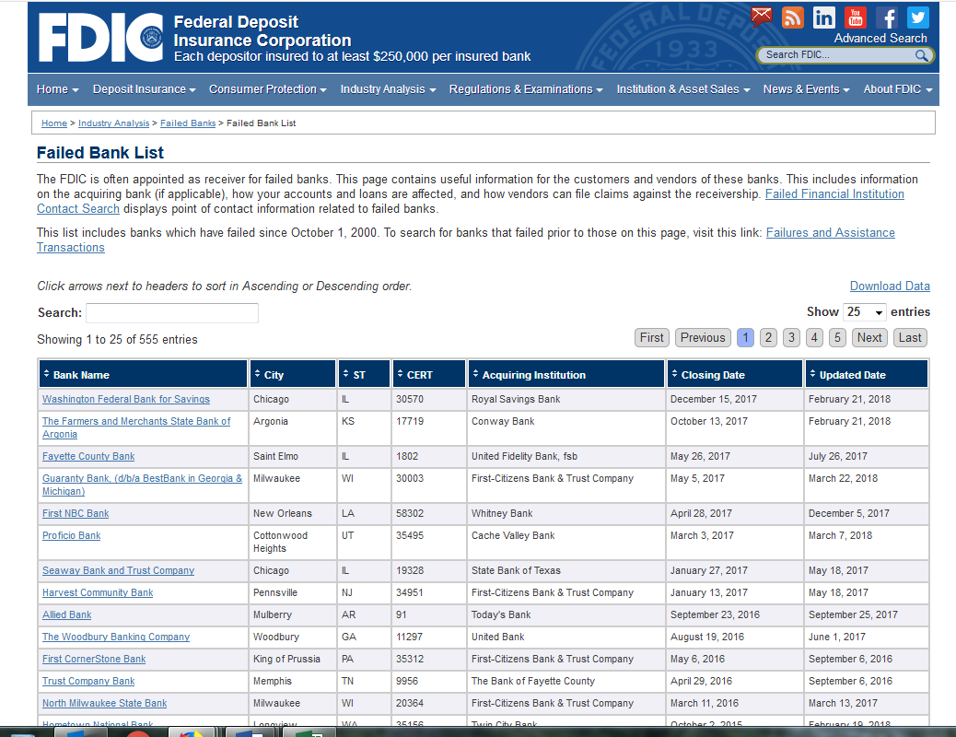
Click on “ST” heading

The table is presented in chronological order, with the most recent bank closure listed first. That will make it easy for you to do a count of banks closed in the US for each year between 2000 and 2019. Record your ‘head count’ in the table/chart below (next page).

Next identify the number of banks closed in Georgia. To arrange the list in alphabetical order, look for the column identifying the State where banks are located (“ST”) and click on the arrow. This will arrange the states in alphabetical order. Scroll down and locate the banks located in Georgia (around page 7). Look at the column entitled “Closing Date” and begin counting how many banks were closed in Georgia in 2000, 2001, 2002, etc. Record the number of Georgia Failed Banks in the far-right column of the table/chart below (next page).

Look over the rate and pace of bank closings in the US and in Georgia and compose your analysis below your completed table/chart on the following page. Save that page as your Business Portfolio Assignment #3. In other words, do not include these instructions in your Portfolio.

Scroll down for the Assignment #3 table.

Business Portfolio Assignment #3

Analyzing Todays Banking Environment

US Bank Closures – 2000 to 2019
Year | Number of Banks Closed in US | Number of Banks Closed in Georgia
2000
2001
2002
2003
2004
2005
2006
2007
2008
2009
2010
2011
2012
2013
2014
2015
2016
2017
2018
2019

SOURCE: http://www.fdic.gov/bank/individual/failed/banklist.html

Begin essay here: Look over the bank closures in the past decade. What do you see in the numbers? Look at the increase and decrease in the number of bank closures. What years saw the most bank failures? What has occurred? What happened to banks in Georgia??? What is the trend now (in recent years)? Think of three or four consequences of this trend. How will this affect you as a consumer? How will this trend affect entrepreneurs and small business owners?
_____________________________________________________________
#4 While on the FDIC website, look at the Historic Data on Banking
(https://www5.fdic.gov/hsob/SelectRpt.asp?EntryTyp=10&Header=1) tab.
Look for “CB01: Number of Institutions, Branches, and Total Offices.”
Hopefully, this link will take you right to the data you need:
https://www5.fdic.gov/hsob/HSOBRpt.asp. But feel free to snoop around the
FDIC website. It is quite revealing!

From the table, identify the total number of banking Institutions and the
number of Branches in 1978. Add those numbers to your Assignment #4
template located in D2L under WEEK 3 Banking Environment tab. Now, look
on the table of Historic Data on Banking, at the number of Banking
Institutions and Branches in 2018 (or most recent data). Add those
numbers to your Assignment #4 template. Look over your table of data of
Historic Data on Banking. What do you see happening to the number of
banking Institutions (companies) in the past 40 years? What do you see
happening to the number of bank Branches in the past 40 years? Do you
think most Americans are aware of this trend? What effect will this trend
have on individuals and businesses, if it continues? Complete Assignment #4
by recording your analyses and reflections on the questions and possible
other questions in 200-225 words composed below the ASGN #4 table you
filled in.

Business Portfolio Assignment #4

Comparison of US Bank Population – 1975 and 2018

INSTRUCTIONS: To access the banking data needed for this Portfolio assignment, click on https://www5.fdic.gov/hsob/SelectRpt.asp?EntryTyp=10&Header=1 to get to this index page:

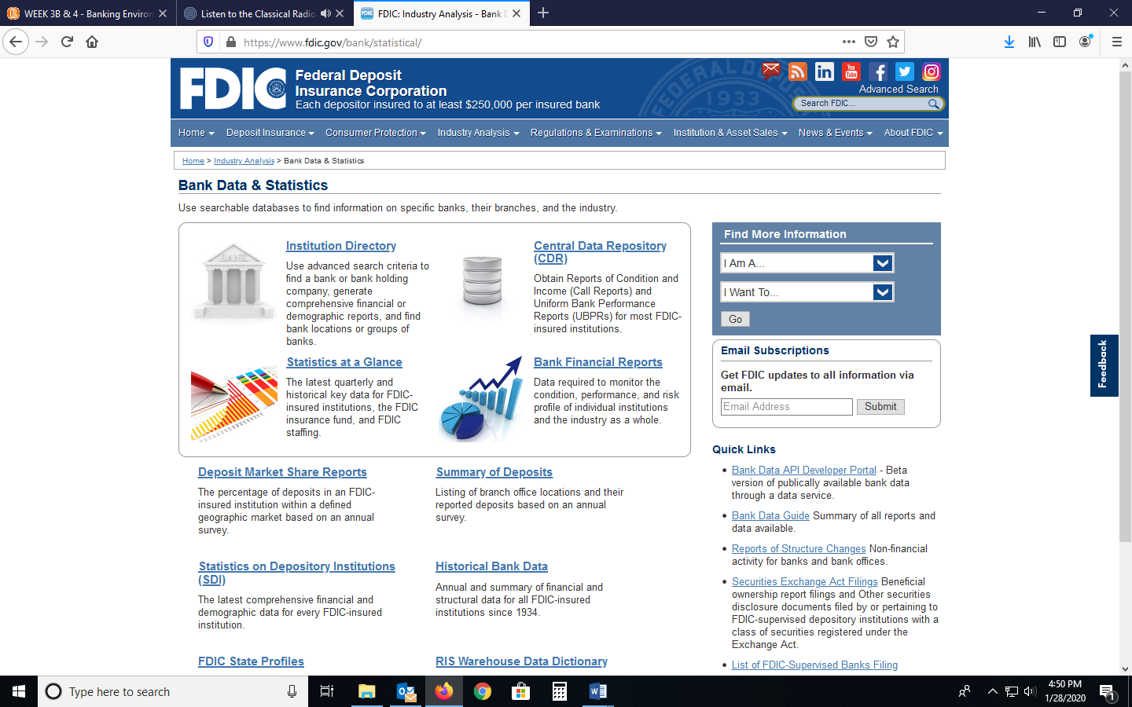

Select “Historical Bank Data” and look for “Filters” on the left-hand margin. Change “Start Date” to 1975. It looks like 2018 is the latest data at this time.

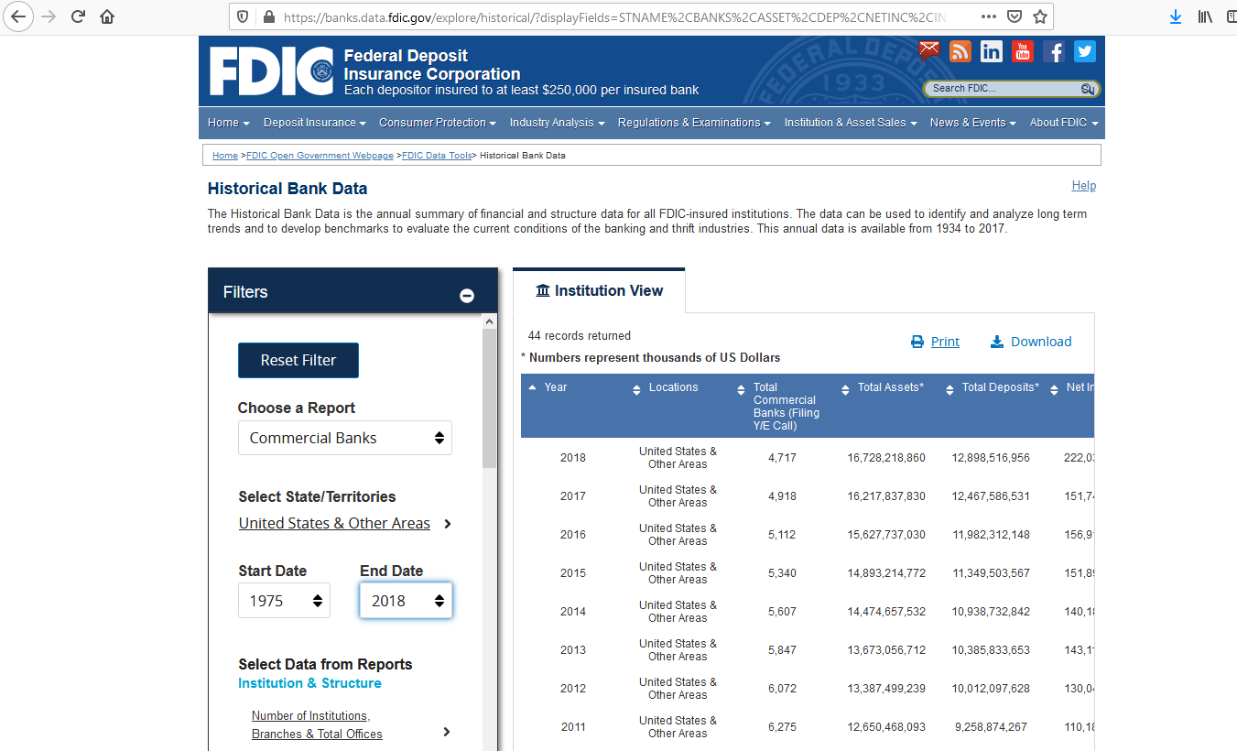
Select this one
In the “Filters” menu, scroll down and look for “Select Data from Reports” menu. Click on “Number of Institutions, Branches & Total Offices” to open the expanded menu. Check the box “Total Commercial Bank” and “Total Branches.” Click on remaining options under “Select Data from Reports” and uncheck items included in the default. This way you will only have data on Year-Locations-Total Branches-Total Commercial Banks. Click the minus (“-“) sign in the “Filters” box to collapse the menu and reduce the amount of stuff on the webpage.

You should now have “44 Records Returned” with the year being the first column. Data for 1975 will be at the bottom of the list, so scroll down.

Scroll down to the next page of these Instructions to see the “Comparison Table” for this assignment. Go back to the webpage and look for the 1975 data. Record in the table below the number of “Commercial Banks” in operation in 1975 and the “Total Branches” in 1975. Back on the webpage, look for the 2018 data and record in the ASGN #4 table.

Look over the data you have collected and organized. What do these numbers mean? What is happening with the number of bank-businesses in the US? Is the number growing? Declining? Before viewing this data, did you realize this change? Do you think the average US citizen is aware of the current trend?

What do you see as some consequences of this trend? What has happened to the number of bank branches? Did you realize this? Do you think the trend in branches has camouflaged consumers’ awareness of the trend in the number of institutions? What could happen as a result of this trend?

Think about these questions as you look over the numbers you have collected. Based on your research, what three recommendations would you offer a small-business manager or entrepreneur regarding the Banking environment of business?

Place your cursor on the “Begin your Essay here….” Line below the data table and begin composing your analysis of the data in 200-225 words. The data table and analysis make up ASGN #4 and should be copy-pasted into your Business Portfolio document following ASBN #3. Save. Often! Business Portfolio Assignment #4

Comparison of US Bank Population – 1997 and 2018

 | 1997 | 2018
Number of Banking Institutions
Number of Branches

Source: Federal Deposit Insurance Corporation Historical Bank Data; https://banks.data.fdic.gov/explore/historical/?displayFields=STNAME%2CNETINC%2CBRANCHES%2CBANKS&selectedEndDate=2018&selectedReport=CB&selectedStartDate=1975&selectedStates=0&sortField=YEAR&sortOrder=desc

Begin your essay….

Assignment #5: Potential Employer
Visit Fortune magazine’s website (www.fortune.com) and look over
their annual list of Most Admired Companies. These companies
generally have superior financial performance compared to other
businesses not on the Most Admired list. Select two or three
companies from the list, possibly companies for which you might
like to work one day, and visit the company’s website. Try to
assess its management commitment to the well-being of its
stakeholders. Look for their comments on Social Responsibility, if
any. If one of the companies has experienced legal or ethical
misconduct, explain how this may affect specific stakeholders.
Rank the three companies on the basis of the information you
discovered and your opinion on their fulfillment of social
responsibility. Explain the evidence you used to rank the
companies. What are the advantages of being on the Most Admired
Companies list? Compose a brief (200-250 words) report of your
investigation, identifying the companies selected and the web
address visited.

Assignment #7 -- The Economic Meltdown
The textbook authors provided some insights (in Chapter 3) into
the causes of the 2007-2009 financial crises in the US that led to
the Great Recession (2006-present) felt around the globe. View
this documentary on the events of the real financial cliff:
http://video.pbs.org/video/1082087546/ (@ 55 minutes). Reflect
on some of the cause discussed in the textbook and presented in
the documentary. You might even read some viewpoints in the
media. (CAUTION: Wikpedia might not be your best source here.
Stick to main stream media like USAToday, Wall Street Journal,
BusinessWeek, AJC, Slate.com, etc.) Note from your research all
the different variables at play at the same time, variables
totally unrelated to each other, yet the combination of these
economic variables created a situation where the economy would
be significantly weakened.

Based on your viewing of the Meltdown documentary and analysis
of the causes, compose a summary of what you understand as the
causes of the crisis. Try to “map out” the precipitating factors as
you understand them. Think about what the responses to the
financial meltdown meant for organizations. (See p. 90-91 in your
textbook for additional insights.) Understanding how the financial
crisis occurred may help you prevent a future economic meltdown.
“Connect these dots” and summarize your ideas and insights in a
200-250 word report format for your Business Portfolio entry for
Chapter 3. Consider how this Great Recession could be prevented
in the future. Let’s try to learn from this one so we don’t have to
repeat it

Assignment #8 Researching the Legal Environment
Gain experience working with the information provided in support
of the Federal Sentencing Guidelines for Organizations
(FSGO), as it relates to business managers. Visit the website of
the US Sentencing Commission at
https://www.ussc.gov/research/sourcebook-2017 and scroll down to look for “2017 Primary
Offenses and Offender Characteristics” link. [If the link does not
work, from the USSC homepage, select “Data and Statistics” from the
menu. Next, select “2017 Primary Offenses....”] Look for the link to
“Education of Offenders in Each Primary Offence Category” (Table 8) and click on the link. [Maybe this link will take you directly to
the data:
https://www.ussc.gov/sites/default/files/pdf/research-and-publications/annual-reports-and-sourcebooks/2017/Table08.pdf]
Study the data in the Primary Offense (crime) list and compare the Offense with the Educational Level of the criminal. What trend do you see, based on the data? What conclusions might be drawn on the relationship of educational level and crimes committed? Compare the Offenses (crime) committed by the most (1) “Less Than High School Graduate,” (2) “High School Graduate,” (3) “Some College,” and (4) “College Graduate.” What conclusion may be drawn from the 2017 data regarding offenses “preferred” by
individuals from the different educational levels? Compose your analyses in a 200-225 word summary and include in your Business Portfolio as ASGN #8.

Assignment #10
Researching the Regulatory Environment
Select
one
(1) of these topics to complete your
Assignment #10
:
A)
Identify and discuss three tools that a business owner can use
to influence government and public policy. Evaluate the
strengths and weaknesses of each approach.
< OR >
(B) What is the rationale for government to regulate the activities
of business? How is the US economy and society served by
governmental oversight? How is the US economy and social
existence shaped by government regulations?

Business Portfolio ~ ASGN #12
Ethics and Actions
In the assigned reading this week, the text authors listed several (but not all) categories of ethical issues. Their list included:
1. Abusive or intimidating behavior (i.e., bullying),
2. Lying or distorting the truth,
3. Conflict of interest
4. Fraud
5. Discrimination
6. Technology / electronic communication
Each week in the news we find Managers that breach ethical standards in one (or more) of these areas. Scan recent news (within six months) and see how easy it is to find an organization (profit or nonprofit) who has engaged in one of these violations of ethics. Read through the news story and summarize the actions of those who acted in one of the unethical behaviors presented in the assigned reading. Be sure to select stories from credible news sources. You will want to avoid blogs and other opinion based sources. Be sure to include the citation of your source at the end of your post.
See if you can identify one of the moral philosophies (presented in Chapter 5) the person used in considering the decision to be right and acceptable. Compose your findings in a 200-225 word entry to your Business Portfolio, ASGN #12. Be sure to label this (and all!) assignment entry.

Example
An older example of this Portfolio assignment topic can be found in a study reported in Time Magazine (July 12, 2012) where researchers found that nurses who experienced bullying, either directly or indirectly, were more likely to say they wanted to quit than those who had not experienced bullying. The researchers found that "merely working in a unit with a considerable amount of bullying is linked to higher employee turnover intentions." A workplace where bullying is allowed is a poorly managed workplace.
The model of justice theory holds that people are motivated toward fairness and doing what is right out of a sense of ethical obligation; that is, it is the right thing to do. Of the three types of justice theory, the Interactional Justice applies in this case, where employees evaluate the communication process allowed in the workplace. Bullying is not only an ethical issue it is also a leadership issue and an economic issue. Employee turnover is extremely costly.
-------------------
Source: Belsky, G. (2012). "Workplace Bullying: The Problem—and its Costs—Are Worse than We Thought," Time Magazine, July 12.
Of course, at 149-words, my example does not meet the entry standards of the Portfolio assignment. But you get the idea….

